ASSIGNMENT-2

Name: Aarya Shelar
Roll No.: 19IT1057
Batch: B(B3)
Subject: ROSPL Lab

Q.1) Develop a complete case study on contributing to any open-source Testing Tools.
A Case Study on Apache JMeter
INDUSTRY
Logistics and Supply Chain
REVENUE
$1.2 Billion
This leading global third-party logistics provider offers a centralized transportation marketplace with a comprehensive multi-modal solutions portfolio — including TL, LTL, intermodal, and other capacity solutions to its customers. To meet their customer needs and growth goals in a rapidly changing market, the client deployed a wide range of applications/interfaces including mobile, web, windows, and automation backed by 100s of microservices.
Identifying the Challenge
To stay ahead of the competition and meet customer’s demand for new features/integrations, the client adopted a successful Agile / DevOps process for faster software development and release cycles. With the increased speed of development, and a heavy dependency on UI & manual testing, QA became a bottleneck inhibiting faster release cycles.
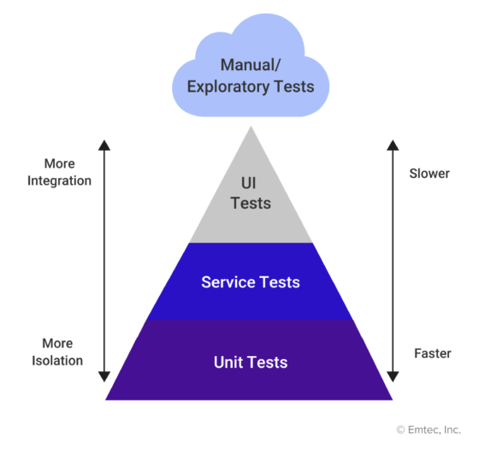
Challenges faced:
- 40+ weekly deployments for various services & applications
- Keeping up with their fast-paced development cycles
- Manual testing was slow and cumbersome
- Changes in UI break the test cases and require constant updates
- Overall delivery schedule & quality adversely affected as number of deployments rise
- Insufficient time for testing applications/services
- Prone to errors and bugs
- Pushing new updates and features into production becoming a challenge
By identifying the challenges of manual testing and their heavy dependency UI testing, it was clear they needed to revamp their testing process and methodology. The next step was to implement new process changes and identify a tool that could alleviate some of their challenges and support their testing efforts as they continued to grow. The tool had to be easy to use while reducing their dependency on manual & UI automation with a higher emphasis on API automation.
The Shift Left & Continuous Testing
As part of the agile development process, the client adopted short 2-week sprint cycles, putting Software development & QA teams under constant pressure to move faster. These fast release cycles resulted in a shorter QA window and testing while improving quality on each successive release.
The ‘shift left’ testing approach was introduced to accelerate testing cycles by injecting testing into each sprint to reduce test failures in later stages of development.

Continuous Testing
The client’s software architecture changed dramatically over a period from Mono-micro, which facilitated faster releases. With the adoption of agile & DevOps, the client can move away from time-bounded releases to on-demand releases as the software is built & tested. Continuous Testing involves applying the methods and concepts of agile development to the testing and QA process, resulting in a more efficient testing process. Continuous testing allows “testing early, testing often” as we develop and acting as a “quality gate” as part of the build pipeline.
These new process changes provide-
- Instant access to feedback by business stakeholders for more informed decision making
- Ability to catch and fix bugs early in the sprint cycle
- Elimination of defects at the source when they are easy to find, quick to fix, and cost less
- Enforcement of “Quality gates” when “Continuous Testing” is part of the CI/CD process
- Increased coverage which reduces risk and defect leakage
- Increased efficiency and reduced technical debt
Implementing API testing provides the following benefits-
- Improved stability and reliability
- Continuous testing as part of CI/CD process
- Greater test coverage
- Extensibility for performance tests
- Reduction in the overall time required for testing
- Improved accuracy
- Increased test coverage
- Support for both manual and automated testing
It was evident that the antiquated testing processes and tools need a revamp to support the frequent addition of new features and releases. Without the proper tools in place, the process will fail. It was time to find a suitable API test automation tool that could accelerate the DevOps process and improve testing quality.
API Automation with JMeter
After an extensive evaluation of various commercial & Opensource tools to automate services, JMeter was chosen as the go-to tool for its simplicity and extensibility.
The following features made JMeter the best option for their needs-
- Open-source tool
- Highly extendable with pluggable Samplers & reusable fragments
- Ability to load and performance test many different applications/server/protocols
- Full-featured Test IDE that allows fast Test Plan recording (from Browsers or native applications), building and debugging
- Extensive reporting with visual charts
- Full multi-threading framework with concurrent execution
- CLI Support can be integrated with DevOps pipelines for continuous testing
- Easy to deploy and use without prior programming experience
- Full multi-threading framework allows concurrent execution
- Seamless integration with third-party open-source libraries such as Maven, Gradle, and Jenkins
- JMeter tests can be executed behind a firewall or on the cloud using BlazeMeter for load testing
- Ability to automate test executions and run the same test on-demand
- Ability to support version control, incremental testing, and environment specific configurations
- Capacity to combine different configuration fragments into one test configuration to comprehensively test functionality
- Ability to create non-functional tests (performance, load, security, penetration, etc.)
Technical Benefits:
- By adopting API automation and “Shift-Left” & “Continuous Testing” methodologies, the client achieved faster release cycles with enhanced features with less dependency on manual testing.
- 100% automation coverage achieved around end-to-end regression workflows
- Integrated APIs to YAML pipeline for continuous testing
- Automated tests executed 24×7 as part of CI/CD pipelines
- Shift-Left approach resulted in a 28% reduction in Software PRBs (Problem Records)
- The ratio of problems to deployments decreased 63%
- 29% decrease in production bugs
- The high/critical problem ratio dropped from 18% to 7%
- Automated API testing resulted in a TTD reduction of 86% during the development/QA phase
Business Impact
API automation reduced the load on the software quality assurance teams so they could focus on value-added tasks. The product owners and software engineers experienced multiple technical and business benefits.
- Accelerated product releases with increased deployment frequency, and quicker deliverables resulting in Faster time to market
- Reduced recovery time with less impact or disruption on users
- Low change/fail ratio
- Software testing and business risks were resolved together
- Better collaboration between the business, developers, and IT team
- Improved security, reliability, and performance
- Business stakeholders have the data to make more informed decisions
- Defects are eliminated at the source when they are easy to find, quick to fix, and least costly to fix

2) Develop a case study on contributing to any open source Network Monitoring Tools
A Case Study on Icinga
Deutsche Telekom Security
Deutsche Telekom Security (T Sec) offers security solutions for numerous customers worldwide as well as for Deutsche Telekom itself. Deutsche Telekom AG is one of the leading international integrated telecommunications companies and is represented in more than 50 countries. Protecting business-critical data, digital identities and networked production facilities from cyberattacks is the mission of the 1,600 employees in Telekom’s security division.
The Challenge
Baseline Situation
Deutsche Telekom Security serves numerous clients from different industries and offers security along the entire digital chain. From network monitoring and protection of client and server systems up to securing industrial systems. The offer includes comprehensive protection for cloud-based infrastructures and managed cyber defense, a Security Operations Center (SOC) for IT security, as well as identity security with digital certificates or complex public key infrastructures. The challenge: “We need a monitoring solution that can handle monitoring for all of the products we offer on multiple infrastructure environments,” says Björn Freese, Operation & Solution Manager for Managed Cyber Defence.

Moving Forward
When T Sec developed a new security solution in 2017 that didn’t fit into their existing monitoring, they decided against an isolated monitoring solution and instead created a contemporary and forward-looking monitoring environment with Icinga.
The Solution
Security First
The multi-client capability of Icinga was convincing – each area sees only those monitoring results that are relevant to them and no others. As a company focused on security products and service offerings, T Sec is interested in another security-relevant aspect: Icinga Agents, that monitor local resources, require SSL encrypted connections with certificate-based authentication. This is also the case for any other connection between any Icinga node. “I didn’t find that in any other product. With Icinga, we keep our focus on security,” says Freese.

Accessible for Everyone
Other advantages for T Sec come with the Icinga Director and Icinga Web. They make it possible to operate with modern dashboards and configuration through the web interface, and thus replace having to write config files. “Linux-savvy colleagues like to do that, but Windows colleagues prefer to put something together in the front end.” Icinga Web is also used by the T Sec Service Desk and Security Operation Center to actively look at it by themselves, because notifications are not sent for everything. “There are checks that I don’t want to have a ticket for, we look at those in Icinga Web.”
Icinga enables a smart workflow for T Sec’s monitoring team. The monitoring engineers provide templates for many different areas, which the responsible persons can use. When new systems are created for customers, the templates including basic checks are used and, depending on the product that must be monitored, Icinga Rules and Services Sets are applied to guarantee that the application is monitored properly.

Flexible, Scalable, High Available
As an open-source product with a lot of active development, an active community, as well as high flexibility and scalability, Icinga convinced the decision-makers at Telekom. “A big advantage is the distributed monitoring. I can put satellites in the internal network or at the customer’s site, connect them with little port activation and have the ability to quickly monitor the respective solutions in the respective environment,” says Björn Freese.
The Icinga setup is built completely following the principle of high availability, with an additional clustered database in the background. The Icinga master is connected to 64 satellites, 30 of them are pairs for high availability, split into 34 different zones. “We still have room to grow and are always looking forward to adding more of our products to be monitored by Icinga,” says Freese. Integrated with Icinga is a ticketing system for notifications and, Grafana for performance metrics. The Icinga Business Process Module is also in use.
Success

Standardized Monitoring
T Sec is now able to monitor their entire product range with Icinga. Including basic parameters of the operating system, but also detailed application monitoring. Icinga monitors a variety of applications and services: From Apache to Java apps, towards to databases and up to clients, APIs, SNMP and many more.
With Icinga, Deutsche Telekom Security has created a uniform, standardized monitoring solution for a wide range of security solutions. “I no longer have the situation where I have different monitoring solutions specialized for different security products. With Icinga we are able to standardize our processes for many of our solutions,” says Freese. Additionally, another perspective has emerged: The need to monitor your customer offerings, starting from the operating system all the way into the application, covering the complete chain of the solution. “This allows us to identify errors quickly and thus improve our KPIs and meet our SLAs.” This is a clear added value for T Sec’s customers.

Supported by Experts
To support T Sec’s reliability towards their customers, they decided to get an official Icinga support contract, which guarantees the required rapid assistance in the event of specific error situations. “We want to have the option to reach out to the experts, otherwise we would have to rely completely on good community,” Freese explains the benefits of Icinga support.

Reliable
Björn Freese describes the ability to manage everything with Icinga Director and Icinga Web as very pleasant. In addition, since implementing Icinga, there is much less manual work involved in monitoring at T Sec. “You rely on it, and you know you’re going to get a notification when something is critical.” Freese’s vision for the future is to go even further into automation with Icinga, to become even more efficient, and to take even greater advantage of Icinga’s capabilities.

Outcomes
- Unified monitoring across multiple platforms and for various customer products
- Smart processes ensuring efficiency and completeness of monitoring
- Ability to integrate and extend for future requirements
- Future-proof monitoring environment, ready to scale up

3) Develop a case study on contributing to any open Source Database tools
A Case Study on Redis
Hulu is an on-demand video streaming platform that has been around for more than a decade. It’s one of the best and largest streaming platforms in the United States, with more than 40 million subscribers.
For many traditional cable subscribers, Hulu also represents an excellent cable-cutting alternative. Not only does it have an enormous library of around 2,500 movies and more than 40,000 episodes from thousands of TV shows, but it also has a plan to stream live TV through the Hulu Plus Live TV program.
Challenges Hulu Faced
The viewed history tracking system was originally designed as a Python application with Memcached for reads on top of a sharded MySQL database for writes. This architecture allowed us to effectively provide the service to our users as we were first building out the system. As our Hulu Plus subscriber count began to grow, we needed the viewed history tracking system to keep up with that growth. We found that the only way to scale MySQL was to add more shards. Additionally, Memcached couldn’t be replicated to other data centers. Traffic from the East coast was having to be sent to the West coast on a consistent basis, so we had our load balancer redirect all East coast traffic to the West coast. As we continued to grow, the architecture wasn’t holding up at peak time.
Given the above challenges,we felt this was a good opportunity to try out a NoSql database as a strategy to boost performance. As we analyzed the problems above, we had four overarching requirements that led us to Redis:
- Speed: The ability for fast writing and retrieval of information.
- Replication: Replication of data across datacenters.
- Scale: The ability to handle at least 10,000 queries per second with low latency.
- High Availability: If one Memcached node went down in the viewed history tracking architecture, we lost 1/n of the cached data. So, we wanted to avoid this problem in the future.
How Redis Solved this problem
After looking at a variety of alternatives like MongoDB, Riak, and LevelDB, we decided to go with Redis. We chose Redis for several key reasons—it was simple to set up, had great documentation, offered replication, and allowed us to use data structures. Data structures are extremely powerful and allow us to architect solutions to many use cases very efficiently. For example, depending on the operation, we have the need to query a specific video a user watched, or all of them. With Redis, this was easy using hashes. By setting one key as the user_id, and the second key as the video_id, you can use hset/hget (key1,key2) for a single video or if you want to retrieve all of them, you can use hgetall(key).
To meet all of our requirements, there were a couple of minor areas that needed additional development. For one, our data consisted mainly of user_id, video_id, and a video position. Since we only query by user and not for multiple users at the same time, we knew we could easily shard on user_id. So, we scale Redis by sharding the data, and the intelligence about shards are in the application logic. As well, Redis didn’t have the sentinel implementation of monitoring and automatic failover when we started redesigning Bigtop in 2012. So, we created our own sentinel mechanism to support high availability.
One of the lessons learned along the way had to do with high availability. We started with client code on top of Redis-Py and used a load balancer with a VIP for the master server and a VIP for slave servers (where slaves serve all reads). Unexpectedly, the load balancer was failing-over incorrectly on a regular basis. After a good deal of troubleshooting, we decided to redesign the solution. We used Zookeeper to keep the state of the cluster, and moved the load balancer code to the clients. There is now a set of sentinels that monitor Redis instances and, if an instance goes down, the sentinels make the failover updates within Zookeeper. Clients listen to events from Zookeeper to update their internal representations. The writes are only sent to the masters, and the reads are balanced on all available slaves for the specified shard.
Other Insights about Redis and Hulu
Besides the fact that there around 4 billion records stored in Redis and around 7k/s queries per second at peak, there are some other elements of our Redis architecture that people should find interesting.
- Once Redis 2.6 came out, it gave us Lua scripting. We use Lua extensively in our application. For example, we created a lookup table to store a mapping of show_ids to video_ids so we can query by show_id instead of by video_id. With a Lua script, we can query for videos of a given show and then query the user’s videos from the user hash in one trip to the server.
- When we needed to be able to sort the viewed videos by updated date for some new queries, we used a ZSET where the score is the updated date, and the content is the video_id. We created a lua script that will use the ZSET to obtain the videos_id of a given user in order and then map the position data from the HASHSET and return it in one trip to the server.
- For performance considerations, we decided to pre-shard the system into 64 instances. We replicate the master shard to a list of slaves in the same datacenter and to a list of slaves in the second datacenter. This way, applications in the other datacenter read locally from the Redis slaves and achieve greater performance. The result was that 75% of the latency in reads that come from the East coast was reduced from 120 ms to less than 15 ms, and the 90% went from 300ms to around 25ms.
- From a durability perspective, we decided to use Cassandra as the persistent data store where all writes are made. Data is then loaded on demand from Cassandra to Redis. The first time a request comes for a user, the system will create a job to load all the videos for this user into Redis. Once this is done, the system will update a flag. The next time a request comes in for this user, the flag is checked. If the flag is set, then the system return whatever it has from Redis without hitting Cassandra. This way access to the database is greatly reduced, and we don’t have to have every record in Redis. To add additional performance improvements, we also built in intelligent querying, where we achieve the low latency reads for active users by having their data uploaded in Redis when queries are faster than Cassandra by a huge margin, and leave Cassandra for batch reports where the latency is not important.
- Since Redis usually can only use one CPU core, and our boxes have 24 CPUs, we are running 16 shards per box trying to achieve a one to one CPU ratio to maximize our hardware utilization. However, when bgsave is enabled, Redis will fork a new process and may even use double the ram. To keep performance consistent on the shards, we disabled the writing to disk across all the shards, and we have a cron job that runs at 4am everyday doing a rolling “BGSAVE” command on each individual instance. We also use this rdb file for analyzing the Redis data without affecting the performance of the application.
- We do a lot of monitoring across all the Redis shards. Specifically, we monitor the number of keys on each instance and size of the database to know when it is necessary to rebalance or expand the shards. Redis has an easy command INFO that gives us all the information needed.

Build JMeter Test Plan
A test plan can be visualized as your JMeter script for running tests. A test plan consists of test elements such as thread groups, logic controllers, sample-generating controllers, listeners, timers, assertions, and configuration elements.
There should be at least one thread group in every test plan. We can add or remove elements as per our requirement.
Let's start building a Test plan by following these simple steps:
Step 1: Launch the JMeter window.
- Go to your JMeter bin folder and double click on the ApacheJMeter.jar file to launch JMeter interface.
- The following image shows the default JMeter interface without any additional elements added to it:
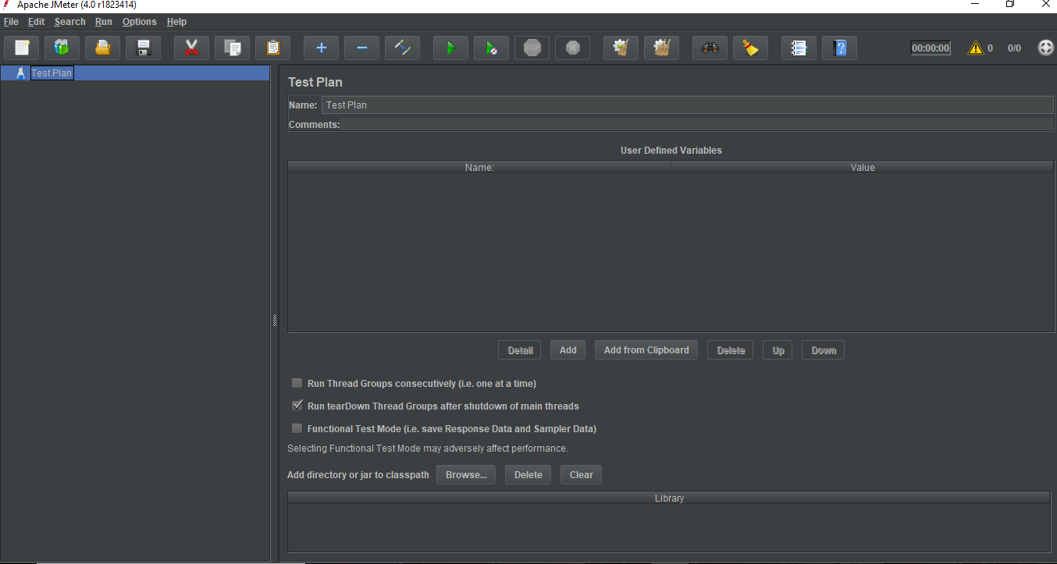
- The default JMeter interface contains a Test Plan node where the real test plan is kept.
- The Test Plan node contains Name of the test plan and user defined variables.
- User defined variables provides flexibility when you have to repeat any value in several parts of the test plan.
Step 2: Add/Remove test plan elements.
- Once you have created a test plan for JMeter, the next step is to add and remove elements to JMeter test plan.
- Select the test plan node and right click on the selected item.
- Mouse hover on "Add" option, then elements list will be displayed.
- Mouse hover on desired list element, and select the desired option by clicking.
- The following image shows how to add a thread group element in a test plan:
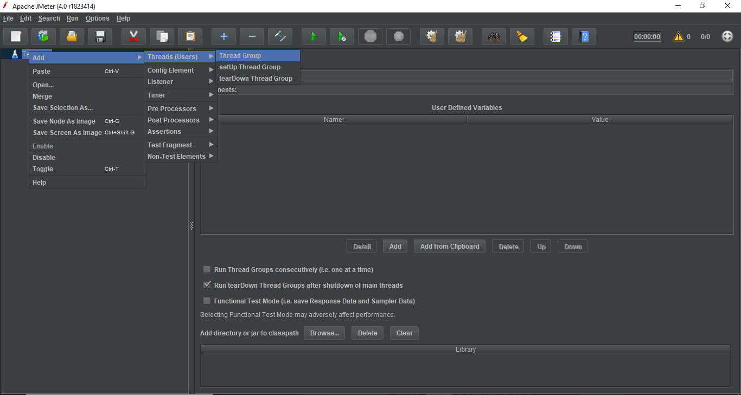
- To remove an element, select the desired element.
- Right click on the element and choose the "Remove" option.
- The following image shows how to remove a thread group element in a test plan:
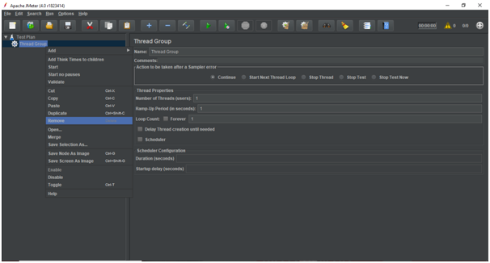

Step 3: Load and save test plan elements.
- To load elements to JMeter test plan tree, select and right click on any Tree Element on which you want to add the loaded element.
- Select "Merge" option.
- Choose the .jmxfile where you save the elements.
- Elements will be merged into the JMeter test plan tree.
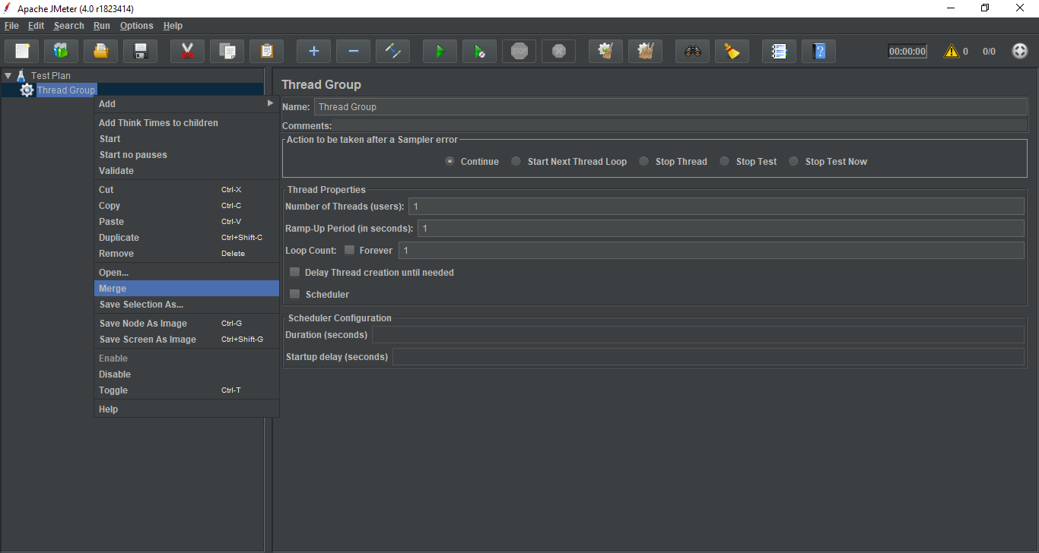
- To save tree elements, right click on the element.
- Choose "Save Selection As" option.
- Save file on desired location.
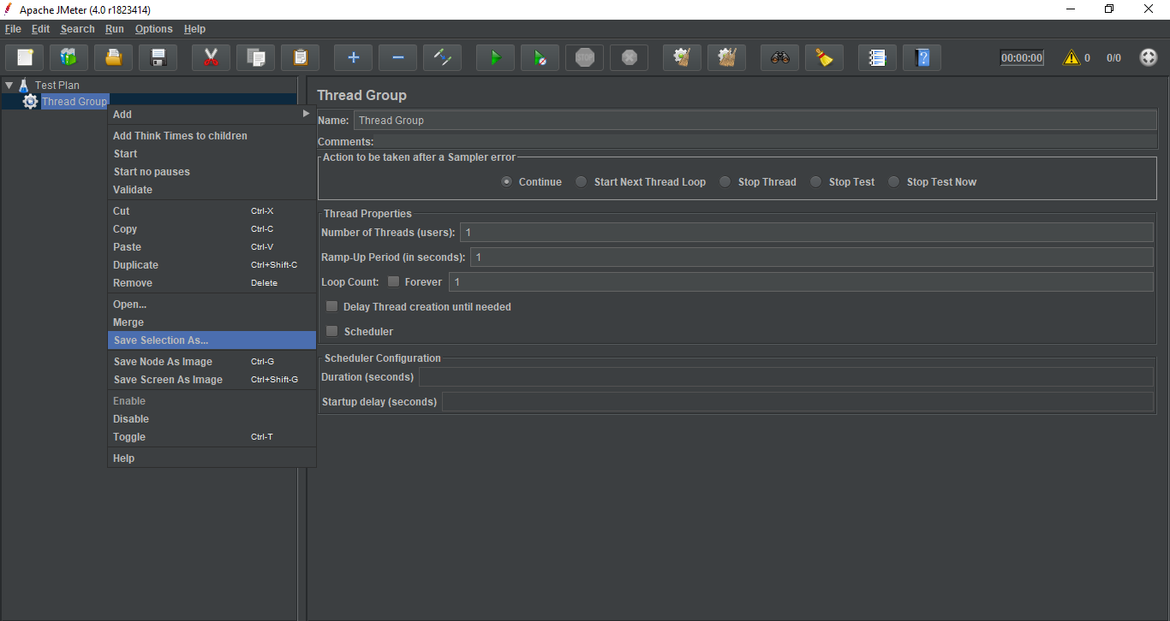
Step 4: Configuring the tree elements.
Elements in the test plan can be configured by using controls present on JMeter?s right hand side frame. These controls allow you to configure the behaviour of the selected element. For example, a thread group can be configured by-
- Itsname.
- Number of threads (the number of users you are testing).
- Ramp-up time (how much time you want to allow the Thread Group to go from 0 to 3 users).
- Loop count (How many times the test should be looped).
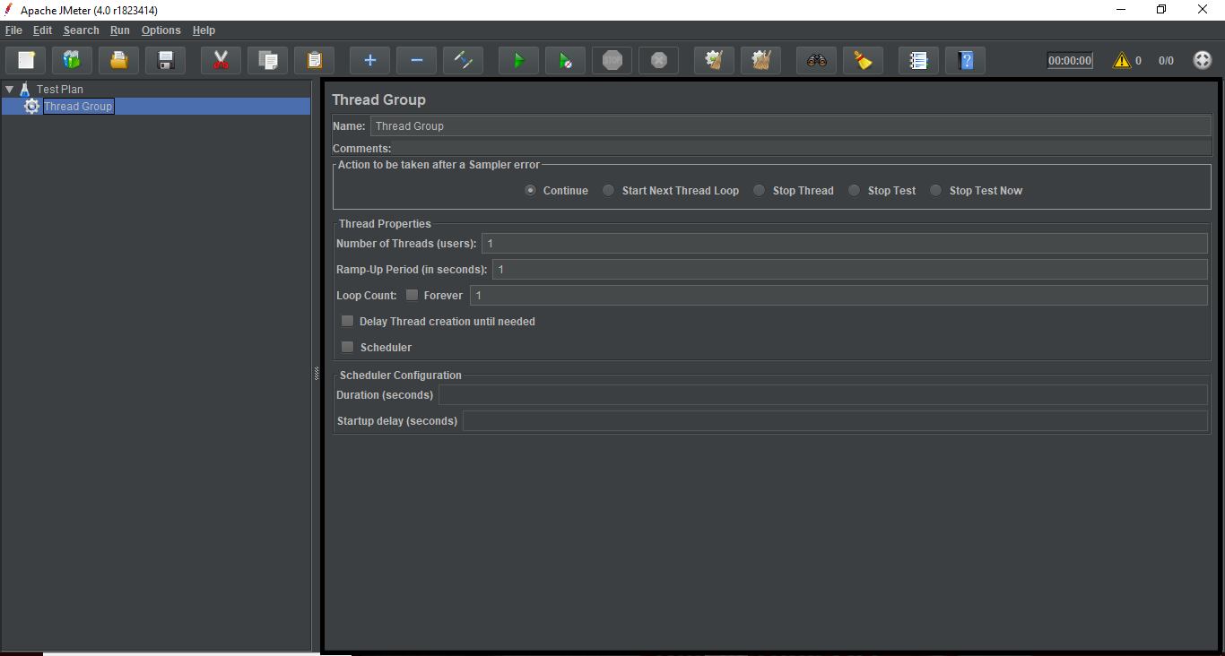
Step 5: Save JMeter test plan.
- Till now we are done with creating a test plan, adding an element and configuring a Tree.
- Now, you can save the entire test plan by choosing the "Save" or "Save Test Plan As" from file menu.
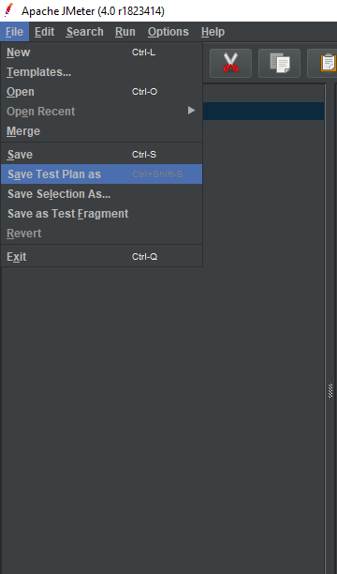
Step 6: Run JMeter test plan.
- You can run the test plan by clicking on the Start (Control + r) from the Run menu item or you can simply click the green play button.
- The following image shows how to run a test plan.
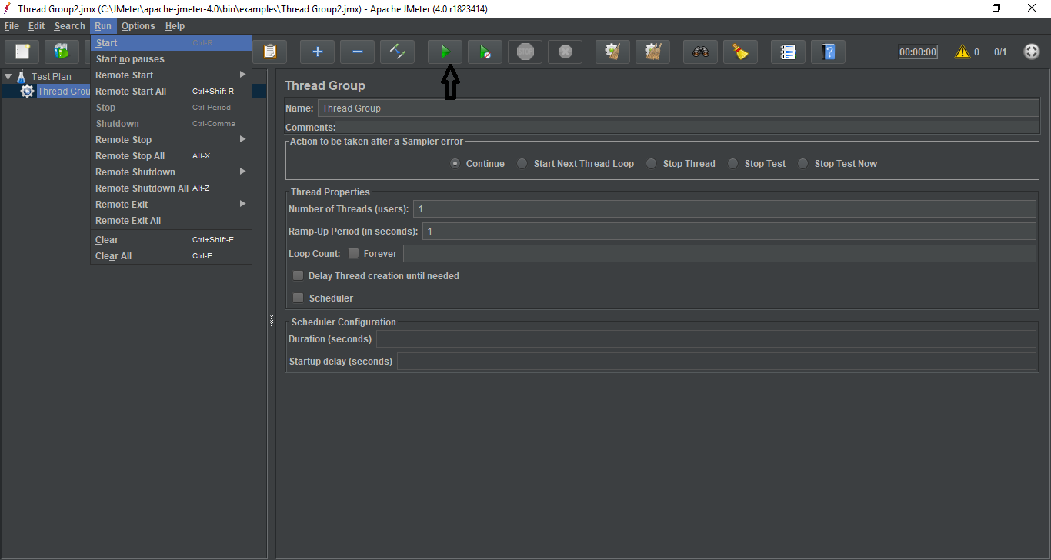
- When the test plan starts running, the JMeter interface shows a green circle at the right-hand end of the section just under the menubar.
- The numbers to the left of the green circle represents:
Number of active threads / Total number of threads
Step 7: Stop JMeter test plan.
- You can stop the test plan by using Stop (Control + '.') - It stops the threads immediately if possible.
- You can also use Shutdown (Control + ',') - It requests the threads to stop at the end of any on-going task.
Step 8:Check JMeter test plan execution logs.
- JMeter stores the test run details, warnings and errors to jmeter.log file.
- You can access JMeter logs by clicking on the exclamation sign present at the right-hand side of the section just under the menubar.
- The following image shows how you can access the JMeter logs:
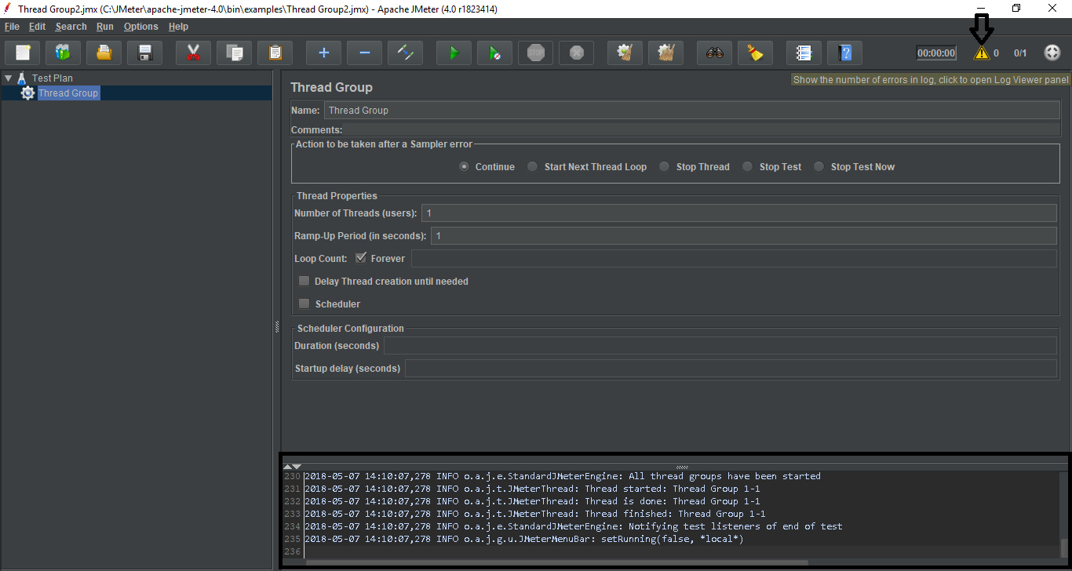

Download Icinga
Implementation

Redis Installation and Implementation
Go to Redis official website https://redis.io/ and follow images given below:
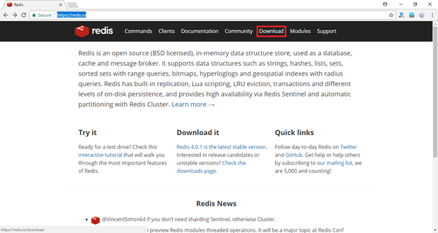
Scroll down to Windows section. You will see learn more. Click on it.
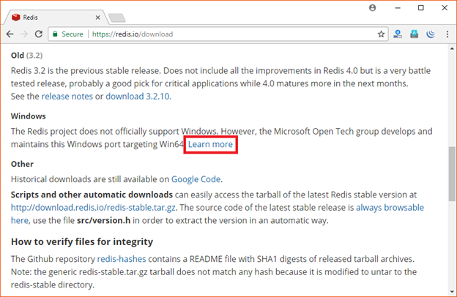
You can also download one click Redis and install as a Windows service.
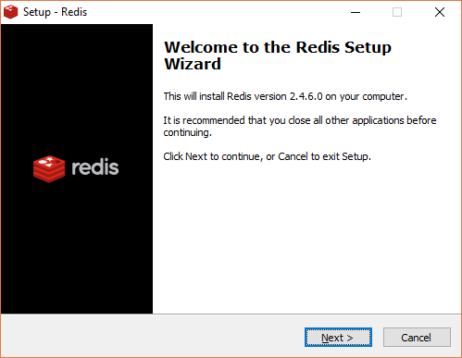
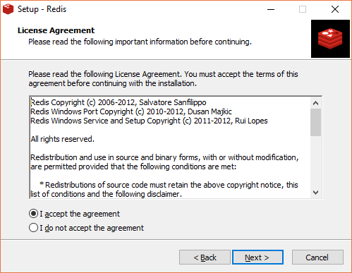
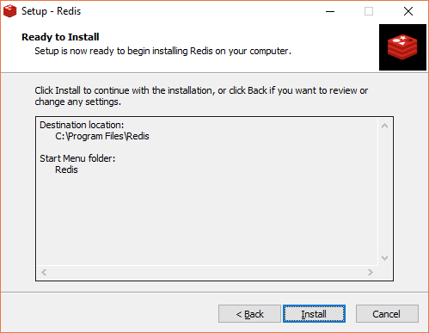
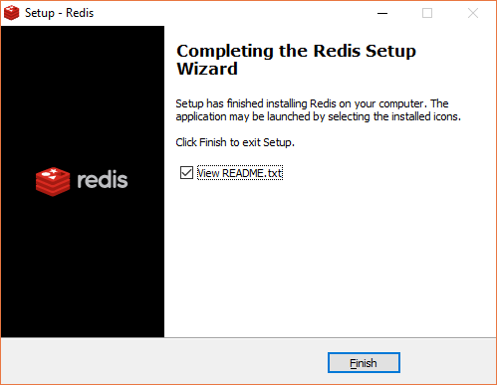
Start Redis
Redis is now ready to use. Start Redis server. Go to program files, followed by redis, followed by:
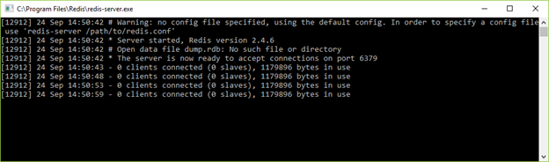
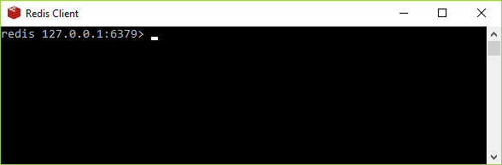
Redis is started. Now you can check whether it is connected.
Use PING command.
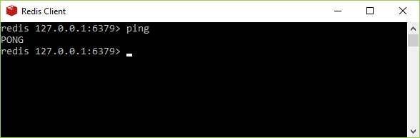
You can see the Redis server. It will also specify that 1 client is connected.
